iFIX HEALTH

BASIC BRAND GUIDELINES PREPARED BY MIX MARKETING / MARCH 2021 MMSL x NOXEN COLLABORATION

**Logo Suite**

PRIMARY LOGO

This version of the logo is to be used where ever possible.

VARIATIONS ICONS

This version can be used whenever the primary logo is not suitable in some instances. The icons can be used when the company name doesn’t need to be present.

PRIMARY COLOURS FONTS MINIMUM SIZE CLEAR SPACE

DUCK EGG

15mm

METERORIC LIGHT

ABCDEFGHIJKLMNOPQRSTUVWXYZ abcdefghijklmnopqr uvwxyz

PMS 5503 C

C50 M17 Y17 K2 R127 G168 B174 HEX 7FA8AE

DARK GRAY

CLEAR SPACE

Other objects should not be placed too close to the logo. The minimum clear space is indicated by the letter 'F' in the logo. More space is preferred where possible.

Duck egg and Gray are the primary colours for the

0123456789

MONTSERRAT

ABCDEFGHIJKLMNOPQRSTUVWXYZ abcdefghijklmnopqrstuvwxyz 0123456789

Questrial (Google Font)

ABCDEFGHIJKLMNOPQRSTUVWXYZ abcdefghijklmnopqrstuvwxyz 0123456789

This is the smallest version that logo should be. Total height of 15mm including the logo type.

C M Y K80 R30 G30 B30 HEX 333333

iFIX Brand.Meteroric Light and Montserrat are the primary fonts. These fonts have been supplied to the client. Questrial is an alternative which can be used in place of Texta when (for any reason) it cannot be used.

MMSL x NOXEN COLLABORATION **Olive Tree** BASIC BRAND GUIDELINES

MMSL x NOXEN COLLABORATION **iFIX HEALTH** BASIC BRAND GUIDELINES ALL LOGOS AND LOCKUPS ARE AVAILABLE IN ALL FORMATS PROVIDED IN THE LINK GIVEN FROM GOOGLE DRIVE ALL LOGOS AND LOCKUPS ARE AVAILABLE IN ALL FORMATS PROVIDED IN THE LINK GIVEN FROM GOOGLE DRIVE

**Business Cards**

MICHELLE WATSON // *Director*

85 Ngatai Road, Otumoetai, Tauranga 3110

**p.** 021 558 093 **e.** michelle@ifixhealth.co.nz

**www.ifixhealth.co.nz**

FRONT BACK

MMSL x NOXEN COLLABORATION **Olive Tree iFIX HEALTH** BASIC BASIC BRAND GUIDELINES BRAND GUIDELINES ALL LOGOS AND LOCKUPS ARE AVAILABLE IN ALL FORMATS PROVIDED IN THE LINK GIVEN FROM GOOGLE DRIVE

**Imagery - Podiatry/Psychology/Dietetics/Massage**



MMSL x NOXEN COLLABORATION **Olive Tree iFIX HEALTH** BASIC BASIC BRAND GUIDELINES BRAND GUIDELINES ALL LOGOS AND LOCKUPS ARE AVAILABLE IN ALL FORMATS PROVIDED IN THE LINK GIVEN FROM GOOGLE DRIVE

**Social Media**

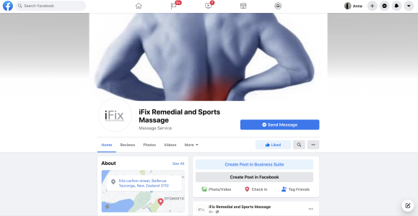

MMSL x NOXEN COLLABORATION **Olive Tree iFIX HEALTH** BASIC BASIC BRAND GUIDELINES BRAND GUIDELINES ALL LOGOS AND LOCKUPS ARE AVAILABLE IN ALL FORMATS PROVIDED IN THE LINK GIVEN FROM GOOGLE DRIVE